Chapter 11, Solution 19.

The variable resistor R in the circuit of Fig. 11.50 is adjusted until it absorbs the maximum average power. Find R and the maximum average power absorbed.

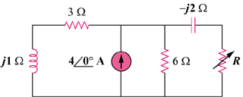

33∠0˚A

Figure 11.50
For Prob. 11.19.

Solution

At the load terminals,

2.576 Ω

To get , let .

By transforming the current sources, we obtain

= 69.16∠12.09˚

P_{max} = = 258.5 W.

